**Experiment name**

SU-8 mold fabrication by soft-photolithography for PDMS microfluidic device and subsequent

PDMS microfluidic device molding

**References**

**Material and equipment**

* SiliconnWafer (<https://darwin-microfluidics.com/products/silicon-wafers-for-soft-lithography-pack-of-25>) ref
* SU-8 2000 is a high contrast, epoxy based photoresist resin. The UV exposed and subsequently cross-linked portions of the resin are rendered insoluble to liquid developers.

<https://www.seas.upenn.edu/~nanosop/documents/SU8_2035-2100.pdf>

2015 less viscous than 2050

Stored in fridge (**M1-109**)

# Photomask : with microfluidic device pattern. Unexposed photoresist is removed using a developer (D) to end up with the final mold. (https://selba.ch/fr/selba-s-a/)

* PDMS Sylgard 184 Silicone Elastomer Kit (https://www.gelest.com/product/DBE-712/)

**Time and technical constraint**

Around 2 hours

**Precise description of the method**

Clean room (**M6-122**):

Contact Physic lab [vincent.dolique@ens-lyon.fr](mailto:vincent.dolique@ens-lyon.fr) 0426233957

**Caution clean room:**

A cleanroom is a room in which the concentration of airborne particles is controlled to  
specified limits. Users may need to bring items in and out of the cleanroom such as tools, equipment,  
stationary, etc. Due to the nature of the cleanroom, you need to be very careful of what items  
are brought in and how clean they are.

* Airlock: put Coverall disposable, bouffant cap, shoe-cover (do not walk on the ground tape without overshoes).
* Certain items are not allowed into the cleanroom, such  
  as non-cleanroom paper.
* Close the airlock doors tightly to avoid getting stuck in the room
* Write protocol on clean room paper rather than notebook. Or laminate it.
* Turn on the light, no UV!
* Use clean room paper, be careful to use the “smooth” side to avoid the deposit of fibers.

**Before starting:**

1. Turn on UV lamp

https://www.hamamatsu.com/eu/en/product/light-and-radiation-sources/lamp-module_unit/spot-light-source/L9588.html

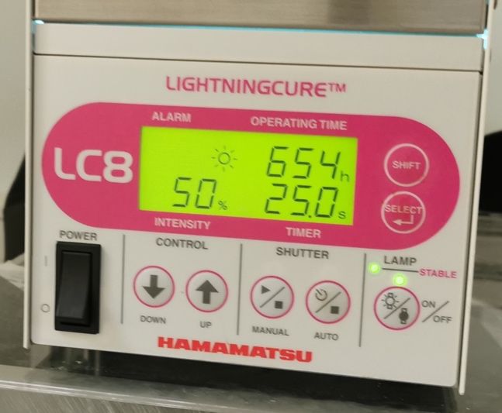

* Power boutons O/I then ON/OFF
* Wait until stable light turn on
* Parameters selection : SHIFT+SELECT

1. Turn on the heating plates (the one on the right 65°C, the one on the left 100°C), place clean room paper on them.

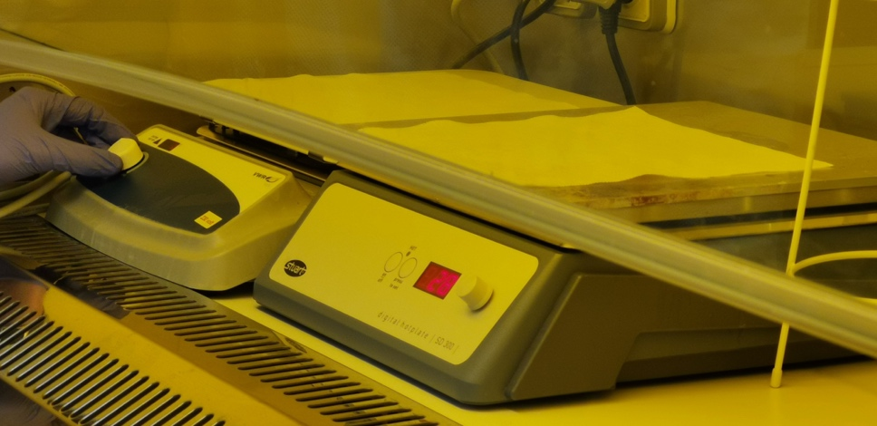

1. Switch on the spin coater (sps spin150), the vaccum pump and open the vaccum valve.

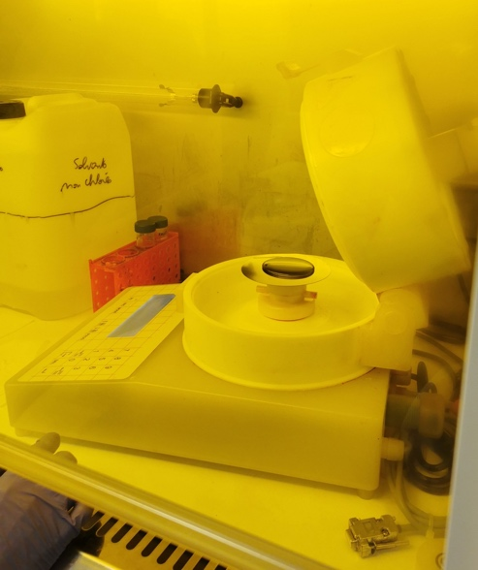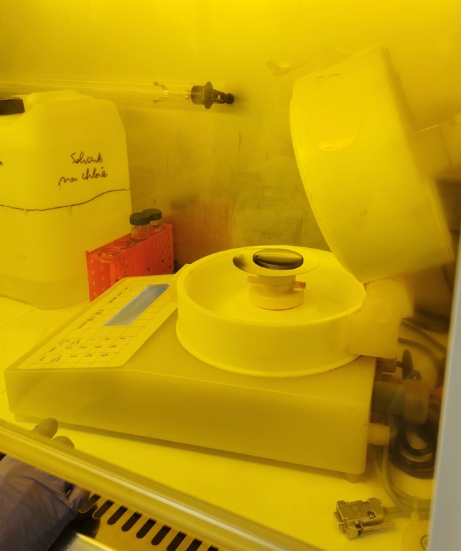

**Spin coating:**

Centrifugal coating of the resin on the wafer. The substrate here our wafer is placed and maintained by vacuum on a rotating plate at constant high speed, in order to spread our resin evenly by centrifugal force. The thickness of the deposited layer depends on several factors: Factors linked to the machine with the angular speed (the greater it is, the thinner the thickness will be) and the time of the operation (the longer the operation, the greater the layer is thin). Factors related to the compound deposited: quantity deposited, viscosity, molar mass... This technique will allow us to deposit the layer of photosensitive resin on the wafer with a thickness of the order of a micrometer.

-Protocol SU-8 2050 (1 layer)

1. Preheat the wafer 10’ à 100°C then let it cool down 3-4’, manipulation by lifting it from below.
2. Place wafer in the middle of the holder in spin coater chamber.
3. Vacuum and spin by hand to assess the position of the object relative to the axis.
4. Turn off the vacuum and readjust until the wafer is centered.
5. Vaccum.
6. Enter the program in the spin coater (modify program 20 for example). Parameters dependent on the resin, consult the instructions for use

(https://www.umu.se/contentassets/9f8c0a0dda844a09b42336a77868b84e/spin150-npp-spin-coater.p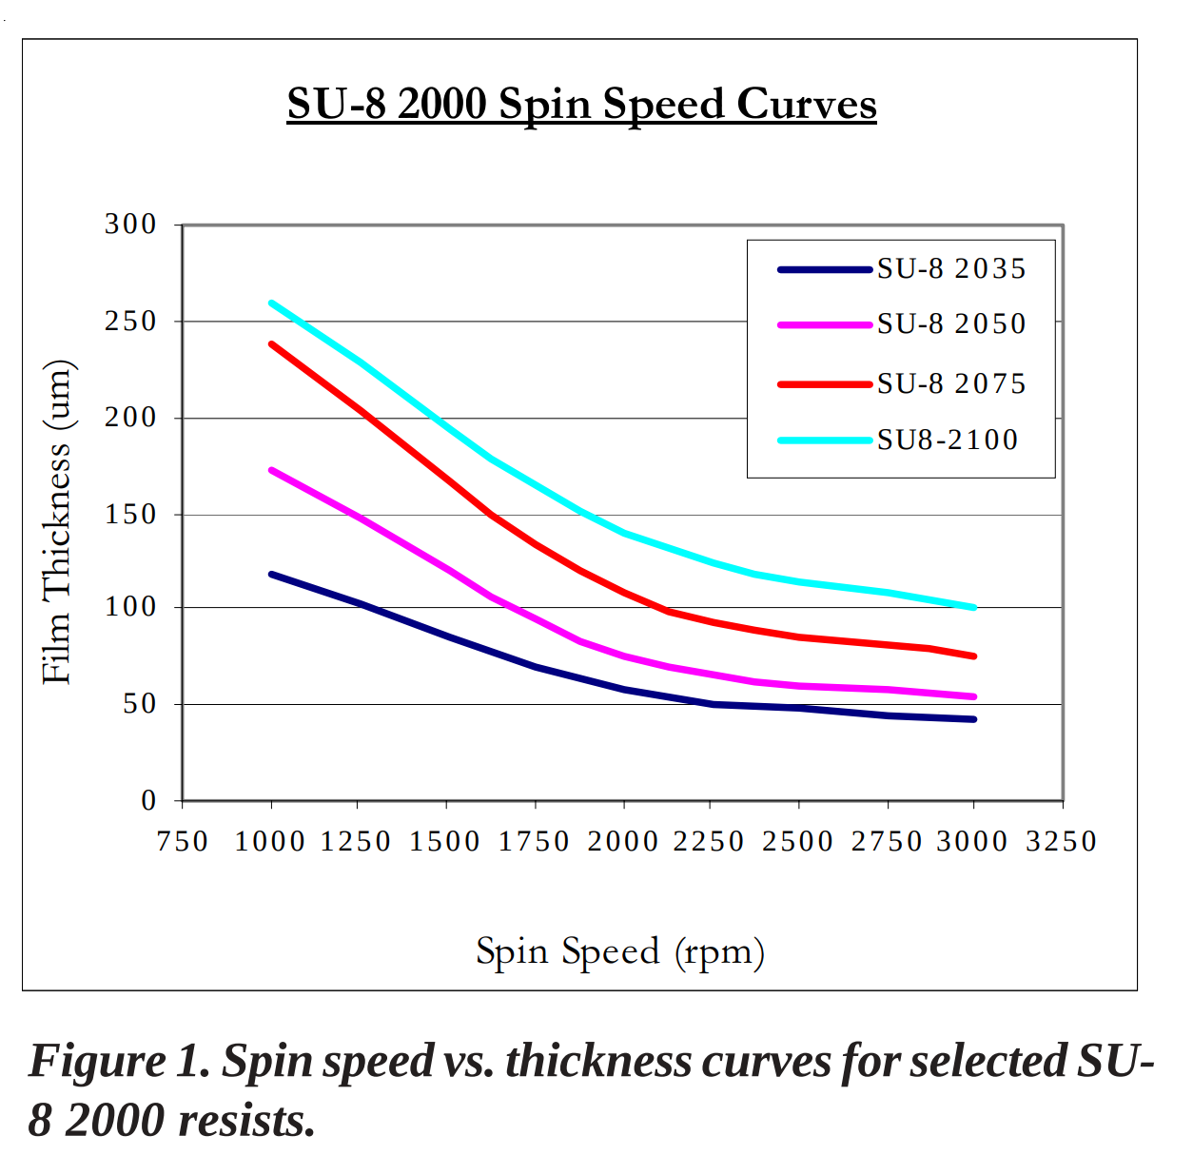df)

Step1 : 500rpm, 10s, acceleration 300 rpm/s

Step2 : 1700rpm, 30s, acceleration 300 rpm/s (expected thickness 115µm)

* + - 1650rpm 80-90µm, 1550rpm for 100µm

1. Aliquot resin in a 50ml Falcon and drop the resin in the center. Avoid bubbles
2. Close the lid and launch the program.
3. Break the vacuum, switch of the pump and close the valve.
4. Switch off the Spin coater.

**Soft baking:**

1. Place the wafer 3’ at 65°C then 9’ at 95°C (thickness >115µm 5’ at 65°C then 20’ at 95°C)
2. Clean spin coater chamber with acetone and clean room paper.

**Expose:**

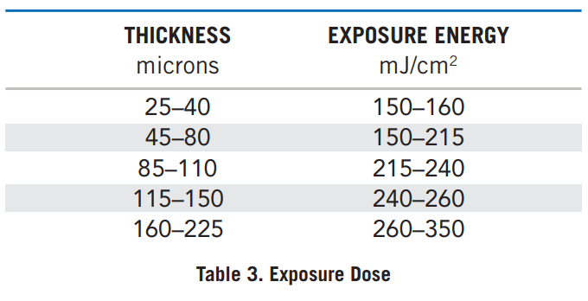

Parameters dependent on the resin + thickness

Test for 115µm Intensity at 50% during 25s (if thickness >115µm 30s).

Prepare sandwich:

1. Place the wafer on clean room paper.
2. Place the mask printed side on the resin.

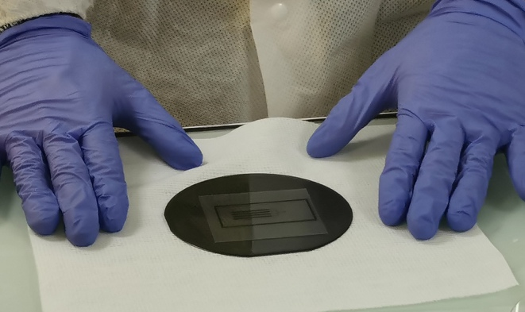

1. Place the quartz disc on the mask (to be cleaned with isopropanol if necessary). Close the sandwich with clippers (preferably small size). Place the clamps in opposite positions to avoid too much stress on the wafer (optional).

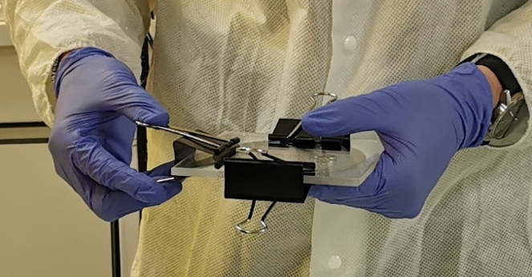

1

3 4

2

1. Place the assembly behind the UV lamp and put on UV safety glasses.
2. Launch exposure by pressing « Auto ».
3. Disassemble the sandwich using pliers if it sticks.

**Hard bake:**

1. 2’ at 65°C then 7’ à 95°C , pattern should appear (for thickness >115µm 5’ at 65°C then 10’ à 95°C).

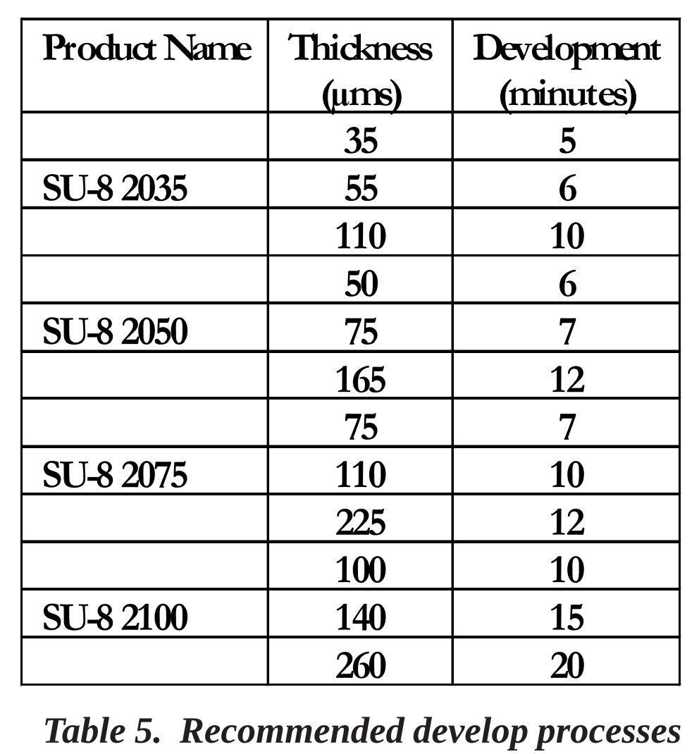

**Develop :**

1. Use recycled developer (SU8-Developper), in a glass petri dish.
2. Immerse the wafer in the developper and make circular movement to remove uncured resin. Strong agitation is recommended for high aspect ratio and/or thick film structures.
3. Agitation for about 7-8 minutes, at least 12 if the surface to be removed is substantial. Do not exceed 15’ otherwise or you will begin to attack cured part and the wafer itself. Be careful, the developper melt gloves!
4. Remove the wafer from the petri dish using suitable pliers.
5. Rinse using isopropanol and dried with a gentle stream of air or nitrogen. (Open the valve).
6. A white film on the wafer indicates under-revelation, repeat steps 17 to 19.
7. Switch off heating plates, UV lamp and the hood and leave the Clean room.
8. Check the pattern under binocular.

**PDMS pouring**

1. PDMS (location…) 30g of PDMS per wafer (36g)
2. Prepare plastic cup and stirrer
3. Compter.
4. PDMS base and the curing agent were  
   mixed at a ratio of 10:1.
5. Degassed under vaccum for 1H.
6. Wrap the wafer in aluminum (large sheet folded over 4 layers) and tighten well on the sides to prevent the PDMS from passing underneath

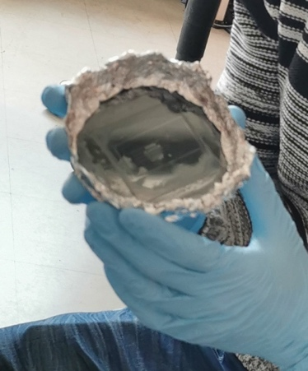

1. Pour the PDMS on the wafer, avoid bubbles. Pierce them with a needle/tweezers.
2. Bake it at 65-70°C during 5H or overnight.